# **PIZZA SALES SQL QUERIES**

1. **KPI’s**
2. **Total Revenue:**

SELECT SUM(TOTAL_PRICE) AS TOTAL_REVENUE FROM PIZZASALES;

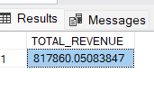

1. **Average Order Value:**

SELECT SUM(TOTAL_PRICE)/COUNT(DISTINCT ORDER_ID) AS AVG_ORDER_VALUE FROM PIZZASALES;

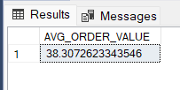

1. **Total Pizzas Sold:**

SELECT SUM(QUANTITY) AS TOTAL_PIZZAS_SOLD FROM PIZZASALES;

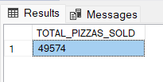

1. **Total Orders:**

SELECT COUNT(DISTINCT ORDER_ID) AS TOTAL_ORDERS FROM PIZZASALES;

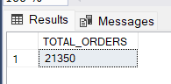

1. **Average Pizzas Per Order:**

SELECT CAST(CAST(SUM(QUANTITY) AS DECIMAL (10,2))/COUNT (DISTINCT ORDER_ID) AS DECIMAL (10,2)) AS AVERAGE_PIZZAS_SOLD FROM PIZZASALES;

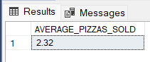

1. **DAILY TRENDS**

SELECT DATENAME (DW, ORDER_DATE) AS ORDER_DAY, COUNT (DISTINCT ORDER_ID) AS TOTAL_ORDERS FROM PIZZASALES GROUP BY DATENAME (DW, ORDER_DATE), DATEPART (DW, ORDER_DATE) ORDER BY DATEPART (DW, ORDER_DATE);

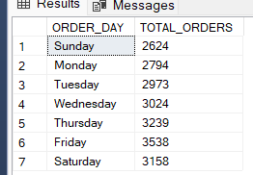

**C.HOURLY TRENDS** SELECT DATEPART (HOUR, ORDER_TIME) AS ORDER_TIME, COUNT (DISTINCT ORDER_ID) AS TOTAL_ORDERS FROM PIZZASALES GROUP BY DATEPART (HOUR, ORDER_TIME) ORDER BY DATEPART (HOUR, ORDER_TIME);

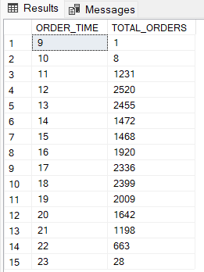

**D.PCT OF SALES BY PIZZA CATEGORY FOR JANUARY**

SELECT PIZZA_CATEGORY, SUM(TOTAL_PRICE) AS TOTAL_SALES, ROUND(SUM(TOTAL_PRICE) * 100/ (SELECT SUM(TOTAL_PRICE) FROM PIZZASALES WHERE MONTH(ORDER_DATE) = 1),2) AS PCT_OF_TOTAL_SALES

FROM PIZZASALES WHERE MONTH(ORDER_DATE) = 1 GROUP BY PIZZA_CATEGORY;

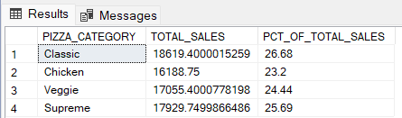

**E.PCT OF SALES BY PIZZA SIZE**

SELECT PIZZA_SIZE, ROUND(SUM(TOTAL_PRICE),2) AS TOTAL_SALES, ROUND(SUM(TOTAL_PRICE) * 100/ (SELECT SUM(TOTAL_PRICE) FROM PIZZASALES WHERE DATEPART (QUARTER, ORDER_DATE) = 1),2) AS PCT_OF_TOTAL_SALES FROM PIZZASALES

WHERE DATEPART (QUARTER, ORDER_DATE) = 1 GROUP BY PIZZA_SIZE ORDER BY PCT_OF_TOTAL_SALES ASC;

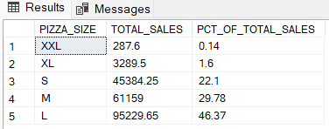

**F.TOTAL NUMBER OF PIZZAS SOLD BY CATEGORY**

SELECT PIZZA_CATEGORY, SUM(QUANTITY) AS TOTAL_PIZZAS_SOLD FROM PIZZASALES GROUP BY PIZZA_CATEGORY;

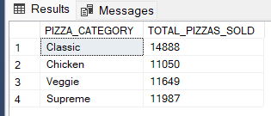

**G.TOP 5 BEST SELLERS**

SELECT TOP 5 PIZZA_NAME, SUM(QUANTITY) AS TOTAL_PIZZAS_SOLD FROM PIZZASALES GROUP BY PIZZA_NAME ORDER BY TOTAL_PIZZAS_SOLD DESC;

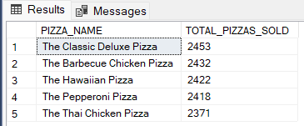

**H.** **BOTTOM 5 WORST SELLERS**

SELECT TOP 5 PIZZA_NAME, SUM(QUANTITY) AS TOTAL_PIZZAS_SOLD FROM PIZZASALES GROUP BY PIZZA_NAME ORDER BY TOTAL_PIZZAS_SOLD ASC;

